Part 1 (4-2)
Write a half-page summary of pre-colonial African leadership strategies.
Check PowerPoint.[ Gender, Sexuality, Spirituality, Environment, and Power in Procol Africa, spring 2020]
Part 2 (4-14)

Write a half-page response to the following questions:
1) What can you discern in the photograph about East African ideas of wealth/power/beauty/fashion?
2) What can you tell about the intended European photographer and publishers’ motives for this photograph? (Don’t forget to take a close look at the historic caption).
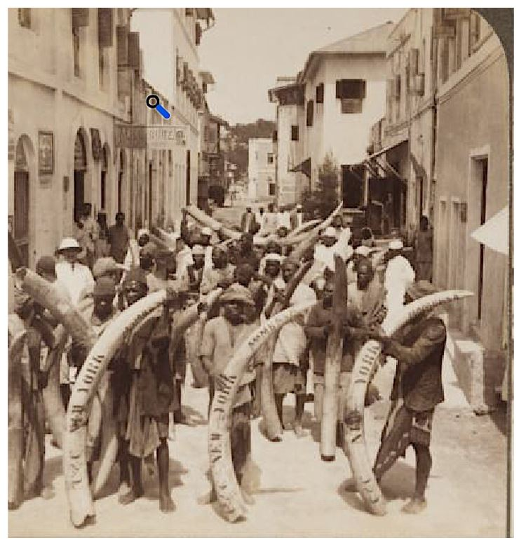
Ivory on the way from the jungle to America, main street, Mombasa, East Africa.
Winterton Collection of East African Photographs, Melville J. Herskovits Library of African Studies, Northwestern University, Evanston. Object 53-14A. 28 March 2017. http://hdl.handle.net/2166.DL/inu-wint-53-14A

Part 3 (4-16)

After watching the documentary from
[ Abina and The Important Men ].
Write half-page double spaced responding to ONE of the following questions:
1. What can be learned about power in 19th Century Africa from this production?
2. Why did Abina bring the case? What issues were most important for her (versus how the court lawyers saw it)?
3. What are your thoughts on this new genre of history textbook: the Graphic History series? What's its potential for college classrooms.

Part 4 (4-21)
Write a short paragraph summarizing how the cartoon demonstrated features of European colonialism.
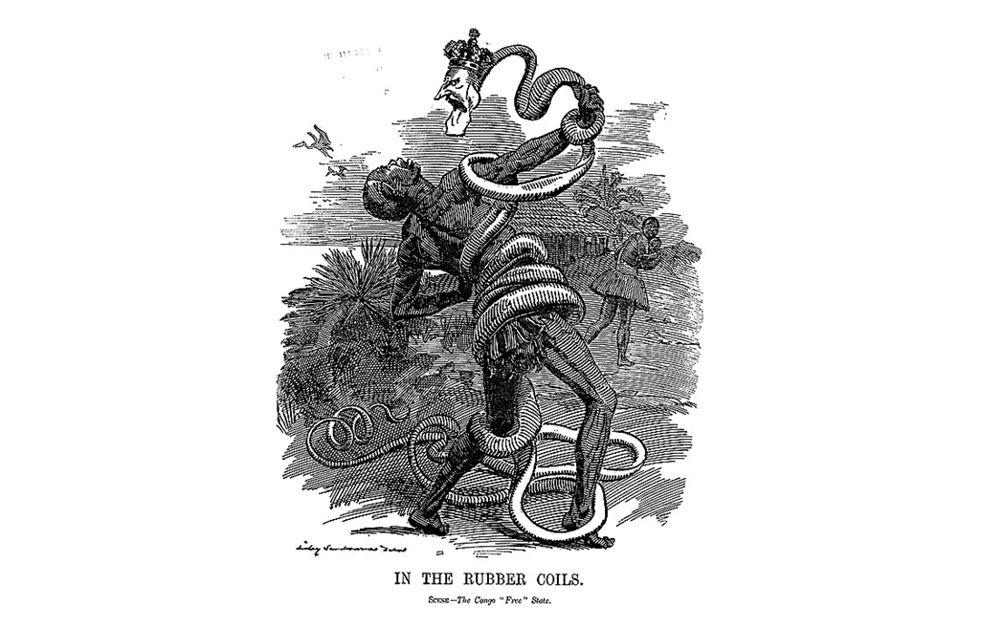

Part 5 (4-23)
Read the short web article and then look at the two short primary sources.
[ https://www.modernghana.com/GhanaHome/ashanti/fante.asp?menu_id=6&sub_menu_id=67&gender=&s=a ]
PDF Files are uploaded for the primary sources.
- BRITISH REACTIONS TO FANTE CONFEDERATION
- Constitution of the New Fante Confederacy
Write half-page on something you learned from these documents.
Here you might think about either what this Fante state would have looked like had it come into effect, the diplomatic strategy of proposing a Constitution to stop colonialism, or how the British reacted.

Part 6 (4 -28)
Book, Pastimes, and Politics by historian Laura Fair.
[ Fair, Laura. Pastimes and Politics: Culture, Community, and Identity in Post-Abolition Urban Zanzibar, 1890-1945. Athens: Ohio University Press, 2001. ISBN: 978-0821413845.]

Reflecting on chapters one and two, please write a half-page discussing one example of the social class divisions or tensions from the early 1900s in urban Zanzibar. There are many examples in these opening chapters so remember you only need some to discuss 1 of them,

